Assignment 1 : Project Ideation
Name: Viddy Virstandi Paramanayaka Andanawari Purnama
- Understand the overview of the Community Portal from Project Mentor.
No | Questions | Answers
1 | What time do you usually browse the internet ? | Everyday, 2-3 hours
2 | What do you think about your Community Portal? | I think my Community Portal will help many people
3 | How can your Community Portal help many people? | It helps a lot of people with people being able to provide information through this Community Portal. And this Community Portal also provides learning tools to improve programming skills
4 | Do you have difficulty in navigating a website? | If the web is big, i have problem navigating it
5 | how do you overcome difficulties when navigating a website? | Using search bar

- Persona
  - List the different personas who will be using the Community Portal, with brief description of each of the personas.
No | Persona | Brief Description
 | Abdul | A 20-years-old programmer who is looking for work experience and wants to improve his skills
 | Siti | A 19-year-old woman who has just finished college and looking for work experience
 | Mahmud | A 25-years-old programmer looking for a permanent job
 | Dian | A 21-years-old woman who wants to improve her programming skills

  - Create a Personas profile with Demographics, Behaviours & Beliefs, Characteristics & Goals for 2 Personas defined.
Persona (1): | Abdul
Demographics: | 20, Male, Indonesian, Unemployeed
Behaviors and Beliefs: | Likes excersices, and traveling
Characteristics: | Sporty, cheerful, and kind
Goals: | Want to lighten the burden on parents who have sent him to school

Persona (2): | Siti
Demographics: | 19, Female, Indonesian, Fresh Graduate
Behaviors and Beliefs: | Likes Vlogging and traveling
Characteristics: | Easy going, and kind
Goals: | Want to be a programmer and work in a big company

Persona (3): | Mahmud
Demographics: | 25, Male, Indonesian, freelancer
Behaviors and Beliefs: | Like Watching Anime and Reading manga
Characteristics: | Hard Worker, friendly, and kind
Goals: | Get a permanent job with a suitable salary

Persona (4): | Dian
Demographics: | 21, Female, Indonesian, employeed
Behaviors and Beliefs: | Likes coding and designing webs
Characteristics: | Hard Worker, friendly, and kind
Goals: | Always want to be the best

- Conduct Ideation for the Project Scenario and come up with 2 Ideas to meet the Project Scenario
Scenario Name: Login Page
No | Ideas
1 | - User opened the site and arrived at home page  - User click login button on the top right home page  - User input username and password and press login button / press enter  - If username or password correct user comes back to home page
2 | - User click login button on the top right home page  - User input username and password and press login button / press enter  - Page will refresh and the blank icon on top right home page will change to user photo

- Create Scenario & Storyboard for one of the Scenarios
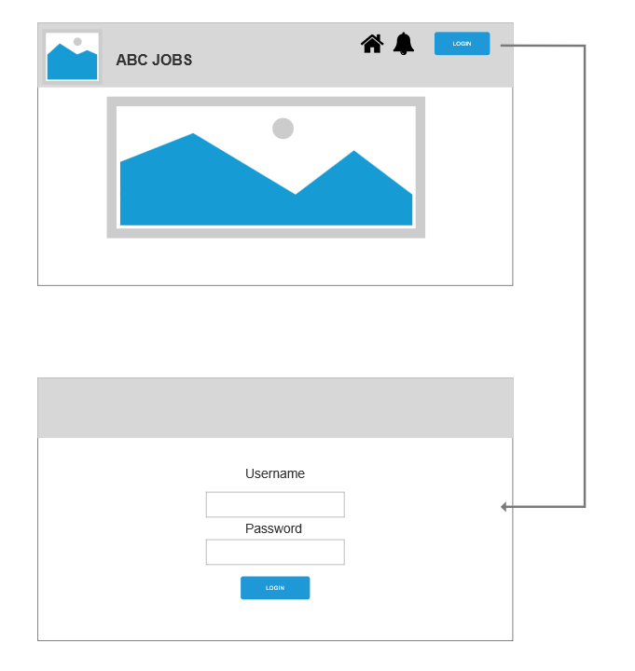
- Use Axure to Create a Wireframe Prototype for 1 Scenario
Scenario Name: Login Page
Wireframe pages | Specifications (Widget Table)
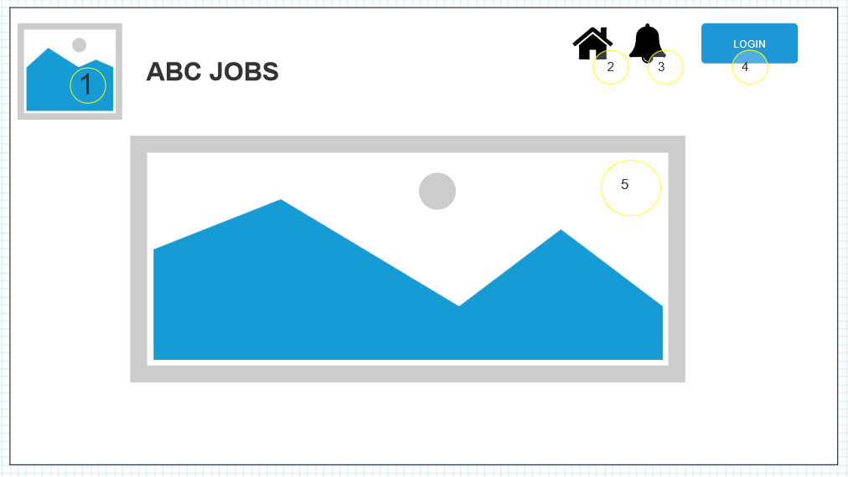 | 1 “ABC JOBS” Logo  2 Home Button  3 Notification Button  4 Login Button  5 Picture About ABC JOBS
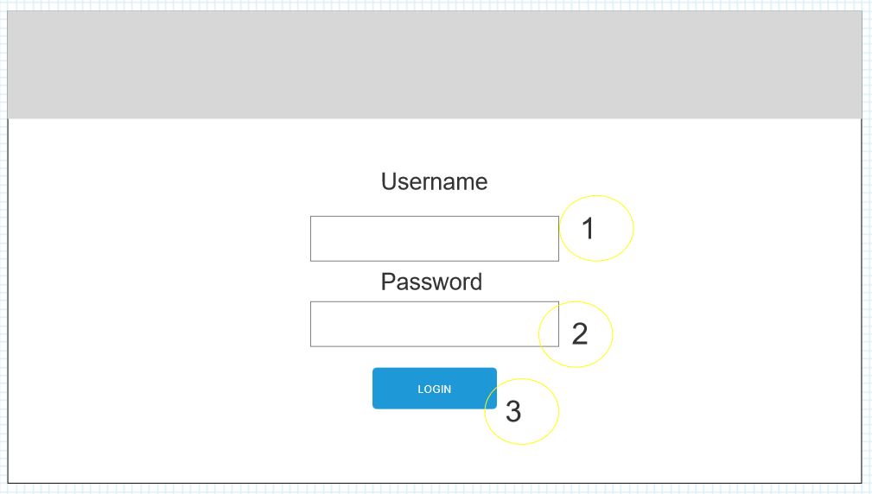 | 1 User Input Username  2 User Input Password  3 Login Button

- Plan the Implementation for the Project Scenario
Priorities | Scenarios
Top | Allow the programmer to register registration confrimation email
Medium | Add checkbox for auto login for the user to if they want to auto login or login manually each time they visit
Nice to have | Popup login page for simple login

